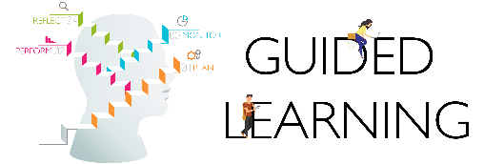

|  |
| --- |
| GL06 – My Learning Log *for submission on LMS: TGL1001 Guided Learning*  to be retrieved from GL LMS under Learning Log (revised on 19 Feb 2020) |

|  |  |  |  |  |  |  |
| --- | --- | --- | --- | --- | --- | --- |
| **Student Name**  **Ng Wan Ni** | | **Admission Number**  **2102041G** | | **Telephone Number**  **84889907** | **Email**  **2102041G@student.tp.edu.sg** | |
| **Facilitator Name**  **Jeannie Ng** | | **School/Dept**  **HSS/NIEC** | | **Telephone Number**  **67805697** | **Email**  **jeannie_ng@niec.edu.sg** | |
| **PLAN** | Consultation _1_ | | Student log | | | **Date/Time/Venue** |
| Connect with Learning Facilitator  Establish GL expectations  Tasks for Refined Learning proposal discussed, agreed for production | | **Key points discussed:**  Learning Contact  Going through my proposal and purpose  Refining my ideas for proposal  **What I must produce for next session:**  Complete and submit my Learning contract  Done some research  Progressions for my e-portfolio.  **Reflection on my learning progress so far**  I need to consider more specifically my learning contract and identify my beneficiary, think deeper and in detail about what I want to do and who and where I would deepen my understanding. | | | **18 Oct 2022**  **3pm – 3.45pm**  **MSTeams** |
| **PERFORM** | Consultation __ | | Student log | | | **Date/Time/Venue** |
| Assigned Tasks for Research on project, project work and e-Portfolio curation completed | | Key points discussed:  xxxxxx  What I must produce for next session:  cccccc  cccccc  cccccc  Reflection on my learning progress so far (what went well, what didn’t go well, what do I need to improve on) | | |  |
| Next steps to progress research, project work and e-Portfolio curation discussed and agreed for production | |
| Tasks to monitor progress and close gaps in research, project work and e-Portfolio curation discussed and agreed for production | |
| **MONITOR** | Consultation __ | | Student log | | | **Date/Time/Venue** |
| Tasks to monitor progress and close gaps in research, project work and e-Portfolio curation discussed and agreed for production completed | | Key points discussed:  xxxxxx  What I must produce for next session:  cccccc  cccccc  cccccc  Reflection on my learning progress so far (what went well, what didn’t go well, what do I need to improve on) | | |  |
| **REFLECT** | Consultation __ | |  | | | **Date/Time/Venue** |
| Practise oral reflection using e-Portfolio as evidence completed | | Key points discussed:  xxxxxx  What I must produce for next session:  cccccc  cccccc  cccccc  Reflection on my learning progress so far (what went well, what didn’t go well, what do I need to improve on) | | |  |